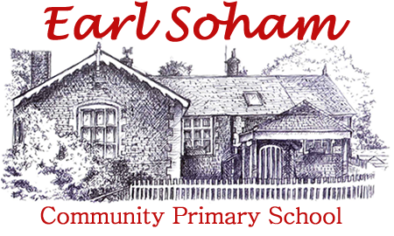

Forest School
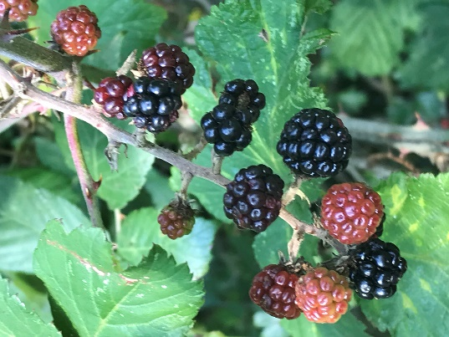

Handbook
2026

Review date 2027
The Handbook contains information, policies, and procedures for running Forest School sessions safely and enjoyably. The Handbook is made available to all supporting staff.

Contents Page
Our Forest School Page 3
Where our Forest School experiences are taking place Page 4
Possible activities for our Forest School Page 5
Benefits of Forest School Page 6
Our Forest School Code of Conduct Page 7-8
Policies, Procedures, and guidance documents Page 9
Safeguarding at our Forest School Page 9
Behaviour policy Page 9
Equal Opportunities & Inclusion at Forest School Page 9
Health & Safety Guidance Page 9
Risk Assessment Policy and Procedure Page 15
General Session Standards Page 19
Forest School Consent/Medical Form Page 20
Communication strategy for all stakeholders Page 21

Appendix
Forest School Risk Assessments

Our Forest School
We believe that all children should have regular, long-term access to a woodland or natural environment to explore the wonders and magic within. It is only through engaging with nature and wildlife that children gain knowledge and respect for their immediate environment. Children learn how to connect with and care for the world they live in. Forest School offers a child-centred approach, where children can learn through self-directed play and exploration. The experience of regular Forest School sessions also helps to build resilient, inquisitive, and create imaginative learners. Working in an outdoor environment offers children time to collaborate, learn to solve problems, and take risks. FS provides endless possibilities for children to follow their own interests, enabling all learners to achieve, which in turn increases self-esteem and confidence. The aim is for this confidence to translate into all areas of life and learning.

Where our Forest School experiences take place
The Field
The 'Hide-out'
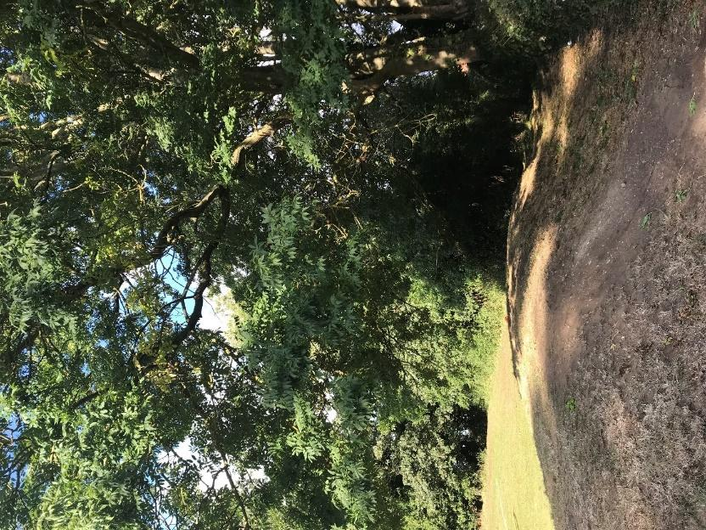
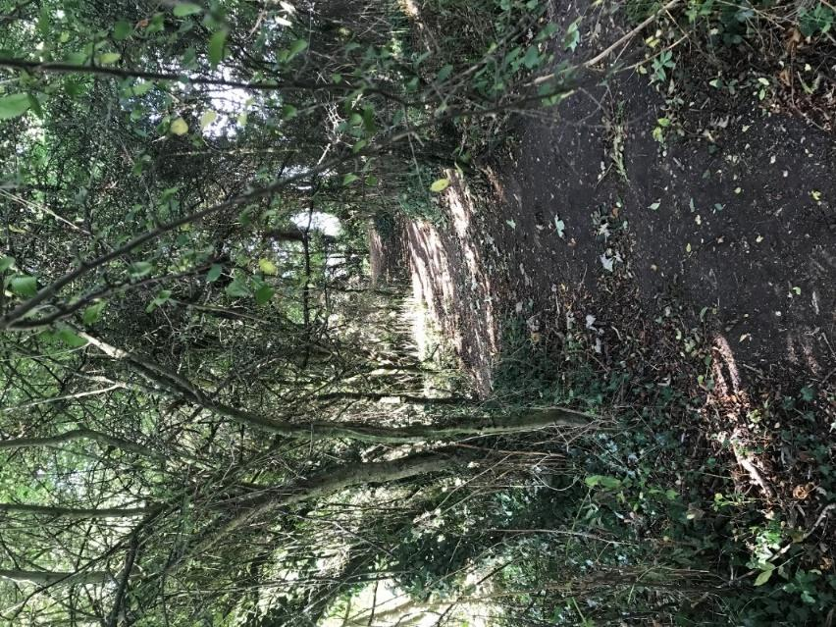

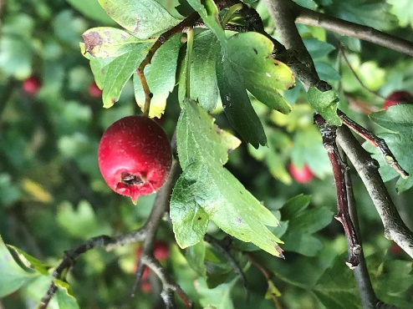
The Conservation Area

The Fire Circle Area
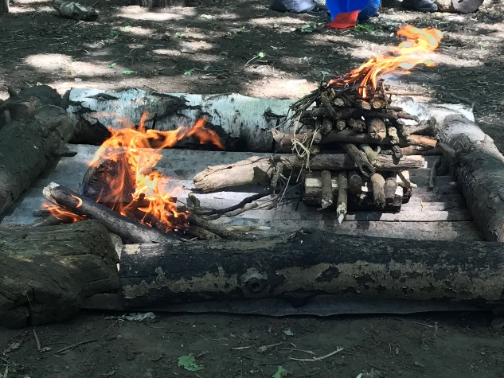
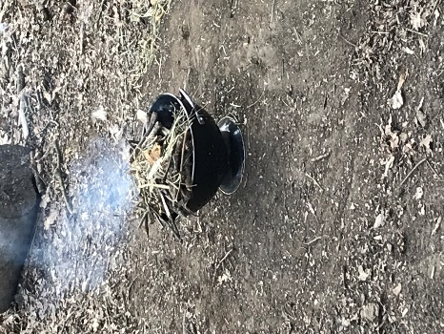

Possible Activities for Forest School
We aim to create opportunities that enable children to discover, create, and become independent learners who can try out their own ideas and explore their own interests at their own pace. The activities are adapted to suit the needs (SEN), ability and experience of the pupils.
Some of these activities might include:
• Building dens
• Fires & Cooking
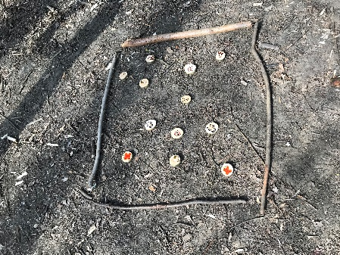
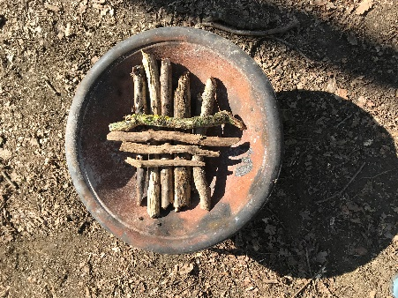
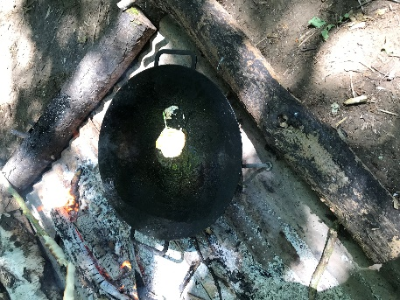
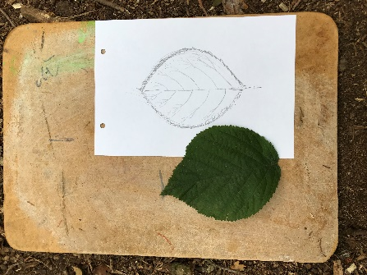
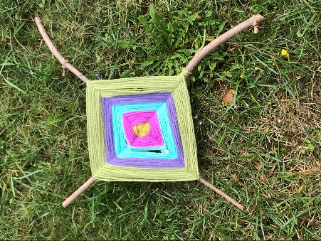
• Nature exploration
• Games
• Natural Crafts
• Tool Use – Saws / Drills /Peelers
• Sensory Activities
• Bush Crafts
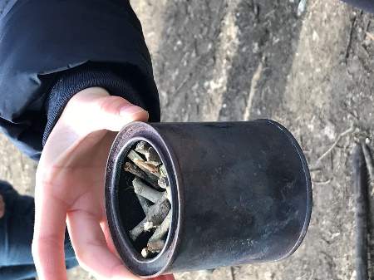
• Seasonal Celebrations
• Scavenger Hunts

Benefits of Forest School
These are:
• Confidence
• Creativity
• Environmental / Risk Awareness
• Motor Skills (Fine & Gross)
• Leadership
• Problem Solving
• Physical Ability – (Balance / Coordination)
• Social Interaction – (Trust / Communication)

Our Forest School Code of Conduct
To ensure safety and appropriate use of equipment, the following code of conduct is shared with everyone involved in the FS sessions.
Entering the Woodland
We will all be respectful of this great resource as we explore and play within it, but know that when we enter, we are entering the home of many different creatures.
Boundaries
All staff and pupils are made aware of the location of their boundary markers.
Carrying & Transporting Materials
All staff and pupils are trained to lift objects safely by bending their knees. Any heavier items must be dragged, rolled, or pulled by hand or with a rope.
Collecting Wood
Wood must never be taken from living trees. It must be taken from the specified area or from the ground. It should be collected in moderation to minimise disturbance to habitats.
Using Rope & String
We use rope and string to tie sticks together to make shelters. Children are encouraged to develop their ideas appropriately to minimise the impact on the environment (GRA)
At the Fire Circle
Fires are lit within the circular seating area.
The children will always move around the fire safely (Green Dragons) and only approach when required (Amber Dragons). Everyone around the fire will watch out for and support each other in keeping safe ... using the phrase "Red Dragon" if someone moves into the fire circle without good reason. If anyone wishes to move, then you must step out of the circle and walk around.
Picking Up & Using Sticks
Children can use sticks, which are shorter than their arm's length.
Eating & Drinking
Unless the session is planned to eat or drink within it (i.e. blackberry picking), pupils are not permitted to eat anything found in the grounds. Pupils are instructed to wash their hands before consuming any food or drink.

Our Forest School Code of Conduct (Cont.)
Lighting a Fire
All staff are briefed, and safety equipment is in place before lighting a fire within the fire circle. Once the fire is lit, it must not be left unattended. (GRA)
Using Tools
All tools have their own clear guidelines. These include: how to use the tool, what protective clothing to wear, the safety distance from others, how to walk with it, and how to pass the tool correctly. (GRA)
Digging
Digging big holes is discouraged as it disturbs the creatures living within.
Toileting
Toilets are available in the school hall.
Tree Climbing
Pupils are permitted to climb trees marked as safe and to climb up to 1.5 metres, but an adult must be present to spot, and the ground must be clear of sharp objects. (GRA)
Leaving the Site
All rubbish must be collected, and any tents, tarps, etc, are taken down.

SRA – Site Risk Assessment / GRA – Generic Risk Assessment
Policies, Procedures, and guidance documents
Safeguarding at our Forest School
All school staff and volunteers have had current DBS (CRB) checks.
Ratios
For children
Foundation stage: 1 adult: 10 children
Key stage 1: 1 adult: 10 children
Key stage 2: 1 adult: 10 children
Earl Soham Community School Child Protection and Safeguarding Policy September 2025.pdf
https://www.earlsoham.suffolk.sch.uk/policies
How Forest School promotes positive behaviour:
Forest School aims to promote a safe learning environment.
Refer to the school behaviour policy- READY- RESPECTFUL-SAFE.

Earl Soham Community School Behaviour policy September 2025.pdf
https://www.earlsoham.suffolk.sch.uk/policies

Equal Opportunities & Inclusion at Forest School
In FS all have equal access to the Forest School site and activities.

Inclusion and Access Procedures:
FS is committed to the principles and practices that support Equal Opportunities and ensure that we do not discriminate against any person on the grounds of:
• Age
• Gender
• Race, nationality or colour
• Marital status
• Disability
• Sexuality
• Religion
• Responsibilities for dependants
• Unrelated criminal convictions
SWT recognises that our policies and practices will have a direct impact on the individuals, communities
and organisations that we work with. We will try to tackle any discrimination as it arises and work in a way
that will provide a positive example to those with whom we work.

Health and Safety

Earl Soham Community School Health and Safety 2019 – Review September 2025
https://www.earlsoham.suffolk.sch.uk/policies

All school staff have up-to-date First Aid qualifications. The Forest School leader also holds outdoor First Aid.

Health and Safety Policy (Specific to FS)
We aim to make children, parents, and staff aware of health and safety issues and to minimise hazards and risks, enabling children to thrive. Risk assessments will be created and evaluated with an understanding that risk is dynamic, and that risk assessments should be dynamic too.
A first aid kit is kept for the treatment of minor injuries by qualified staff. A record of all incidents is kept.
Our first aid kit complies with the Health and Safety (First Aid) Regulations 1981; a designated member of staff regularly checks it and restocks it as necessary.
The Forest School Leader holds a current first aid training qualification. Any injury requiring General Practitioner or hospital treatment to a child, school staff or a helper is logged and reported to the head teacher and governors.
Staff will use protective equipment when handling bodily fluid spills.
The site and equipment are regularly checked for damage or hazards, and any issues are addressed immediately and appropriately.
Any incidents or 'near misses' are recorded in the Emergency Procedures Record.
Children learn about health, safety and personal hygiene through the activities we provide and the routines we follow.
Only staff will have unsupervised access to the children, including helping them with toileting.
All equipment is regularly checked for cleanliness and safety, and any dangerous items are repaired or discarded. Children are taught to handle and store tools safely.
Physical play is constantly supervised.
Hand washing facilities, including anti-bacterial gel, will be available on the school site.

Emergency Plan and Procedures
Emergency Services Dial 999 and ask for the emergency service.
Be ready with the following information:
1. Telephone/Mobile number
2. Location – Earl Soham School, Earl Soham. Grid ref: IP13 7SA TM233632
3. Description of the problem
4. Meeting place for Emergency Services- Earl Soham School car park

What you need to do
• Assess the incident and prioritise actions/injuries.
• If necessary and you are appropriately trained, offer first aid.
• Check the rest of the group. Make sure individuals are comfortable and safe.
•If necessary, contact the police, ambulance, or other relevant service; they will take the details of the young person and have their consent form ready.)
• Stay where you are and wait for the Emergency Services to arrive (one member of staff will be sent to meet the emergency services at the nearest entrance)
• Inform office staff at Earl Soham School. They will inform the Head Teacher and parents.

Food and Drink Policy
Eating is a social time for children and adults, and helps them learn about healthy eating.
When a child starts school, we find out from parents their children's dietary needs, including any allergies. This list is taken from all Forest School activity sessions.
Fresh drinking water is constantly available for the children. We inform the children how to obtain water and that they can ask for it at any time during the session/day.
Hands are washed before eating or snacking.
All staff and volunteers are fully informed about individual children's dietary needs. Children receive only food and drink which is consistent with their nutritional needs and their parents' wishes.

Outdoor cooking, including food hygiene
During the session, we cook a range of snacks and meals, for example popcorn, damper bread, elderflower fritters, or nettle pancakes, over the fire. The FS leader holds a current Food Hygiene Certificate and will ensure that food is handled safely.

Severe Weather Conditions
In severe weather conditions, for example, a storm, Forest School will be cancelled. The Forest School leader and Earl Soham School staff will make this decision. If the children are at the Forest School site, a decision will be made to escort all children and adults back to school. The Leader may decide, if heavy rain is present, to find shelter and adjust the session to the situation (mud cakes / sensory activities).

Fire Risk Policy
Earl Soham School aims to develop children's self-esteem, independence, and motivation, and to keep children safe wherever they are. Campfires are an important part of Forest Schools. Whilst using fires, the area is clearly set out, the staff-to-child ratio is increased, and safety rules are followed ('Log Circle' rules):

Location
• Fires are only lit in the Fire Circle and are lit in a fire bowl or enclosed by logs to prevent the spread of fire.
• Fire is always supervised by the Forest School Leader and never left unattended when lit.
• Safe fire practice is always adhered to.
• There should always be a minimum of 5 litres of water and a fire blanket cloth next to the fire.
• Children, staff and volunteers will be taught and reminded of the 'Log Circle' rules: Enter the circle through the logs and move around the circle in either direction until everyone is standing behind a log. Step over and sit on the log. Children are not allowed to move, cross or step into the circle without permission or a good reason.
• Children are not allowed to bring anything into the fire circle and should not throw anything onto the fire.
• Appropriate training and instruction should be given to everyone (including children).
• Any accident or near miss should be recorded and evaluated
• Sticks should be placed, not thrown, from the side of the fire. The hand should not go over the fire.
• Safety gloves should be available and consistently used.
• All fires should be extinguished at the end of each session.
• Water should be dripped onto the fire to dampen it down.
• At the end of the session, the fire should be doused with water, and the top build-up of potash should be removed. Water should be poured on until the smoke and steam have ceased.
• Children should be seated at least 1.5m away. Fires must be rechecked at least 30 minutes after to be certain they have been extinguished.
• Participants will only be allowed to light fires under the direct supervision of a trained leader using suitable materials and equipment.
• All participants will be given clear guidelines about how to behave and move around the fire pit area when the fire is lit.
• A lit fire will be supervised by an adult at all times, as will all cooking activities.
•All fires should be fully extinguished and all traces removed at the end of a session. Refer to the SRA & GRA.)
Equipment and Resources Policy
Children are taught how to use equipment safely.
We will risk assess their use and supervise children when using tools.
We provide natural and recycled materials which are in good condition and safe for the children to use.
We regularly check all resources and equipment and repair, clean, or replace any unsafe, worn-out, dirty, or damaged equipment (an inventory records the dates and results of these checks).

Tools Policy
FS aims to ensure that all our pupils using the tools do so safely and with reduced risk. Tools that may be used on sessions include potato peelers, bow saws, hand pruning saws, loppers, drills and even sticks!
Whilst using hand tools, the staff-to-child ratio is increased, and safety rules are followed (attached to each tool): 1:2 for bow saws and knives.
Staff-to-child ratio of 1:2 for potato peelers until proficient, then 1:4. Tools to be kept in the Tool Bag, and only one type of tool to be removed at any time. Tools to be counted in and out.
Tools must be used safely and following instructions ('Tool Talk'). Staff, volunteers, and children should receive a Tool Talk before using any tools. They should be informed of potential risks, hazards and working methods to minimise these. Appropriate training and instruction should be given to everyone (including children). Any accident or near miss should be recorded and evaluated. Forest School sessions use a range of tools, believing that this helps pupils develop new practical skills and build their confidence. FS aims to ensure that all our pupils using the tools do so safely and with a reduced risk. Tools that may be used on sessions include potato peelers, bow saws, hand pruning saws, loppers, knives, bill hooks, drills and even sticks!
'Tools Talk'– introduction to, safety, storage, rules
All Forest School helpers will receive a practical induction to safe tool use before helping in any session.
No child removes a tool from the toolbox without asking a helper. This needs to be agreed with the children at the start of Forest School. It is then the helpers' responsibility to ensure that the child knows to replace any protective cover and return the tool to the toolbox when they have finished with it, i.e., it is not left lying around or without a guard.
The following generic safety guidelines are to be followed when using tools, after seeing the Leader demonstrate how to use the tools safely:
• Create a designated tool storage area
• Designate a specific area when using tools
• When using the tool, make sure you are two arms and a tool away from anyone else (except your partner when using the bow saw). Ensure you are demonstrating the correct technique on sawing tools, and wear a glove on the helper's hand.
• When not using the tool; Put it down with the handle facing out and the blade facing in (Partly finished) Place protective cover back on to the tool (if tool has one) Put it in the designated place or in the toolbox provided (Once finished) Fires are an essential part of understanding how to reduce risk within our Forest School sessions. This opportunity helps our pupils develop new practical skills and build their confidence in handling real risks. Fires
Clothing and Protective Clothing Policy
Suitable clothing and appropriate footwear must be worn at all times (long sleeves and long trousers, no open shoes or sandals). Clothing should be weather- and season-appropriate.
Protective clothing must be worn when using tools or working with fire.
• Winter Clothing: Waterproofs/coats, fleece/jumper, hats and gloves
• Summer Clothing: Waterproofs, fleece, sun hat, long-sleeved tops and trousers
• Footwear: Wellies or strong/sturdy (waterproof) outdoor shoes & warm woollen socks
Toileting
Toilets are available in the hall.
Hazardous Plants & Fungi
The risk assessment identifies hazardous plants and alerts the group, so that all members are aware of the dangers.
Biting & Stinging Insects
Insect bites and stings are pretty common and usually cause only minor irritation. In rare cases, pupils can have severe allergic reactions to bites or stings, which may require immediate medical attention. If the pupil is aware that they have an allergy to bites and stings, they first need to inform the school of their allergy and bring in relevant medication.
Medication & Signing
Before pupils leave school, they must sign out their medication. Pupils with care plans have them stored within their medication box. Whoever signs out the pupil's medication is responsible for returning it to school. All pupils will be signed out, with the time and destination stated on the form.
Individual Risk Assessment (IRA)
These assessments will be undertaken for pupils who have medical conditions or whose behavioural needs require them. Leaders/volunteers will be informed of pupils with IRAs when planning & reminded before the session.
Reporting Incidents and Accidents
Once an incident or accident occurs, the Leader must immediately attend to the person in need. The incident is to be logged upon return to the school, and all necessary FS forms are to be completed.

Visitor Policy

All visitors are expected to sign in at the school office and are asked to read the safeguarding leaflet before joining a session. All visitors and volunteers are provided with the FS Handbook and policies. Visitors and volunteers are required to wear a visitor lanyard.

Risk Assessment Policy and Procedure
Earl Soham Primary School is fully insured, and insurance is renewed annually.
Forest School helps children learn how to appropriately self-manage risk in an increasingly risky world. To ensure the safest possible outcomes, the staff-to-adult ratio is high.
The aim is to encourage children, parents and staff to be aware of health and safety issues and to minimise hazards and risks, enabling children to thrive.
Extensive risk assessments are carried out for each forest school session. These include: activities, site, weather and any student's personal risk assessment.
Staff and helpers are given access to all risk assessments and are asked to familiarise themselves with them.
Our Forest School site must be safe and accessible.
- Look for the hazard/s
- Decide who might be at risk
- Evaluate the risk/s and decide what precautions need to be put in place
- Decide if any further precautions need to be put in place
- Review the assessment and revise if necessary

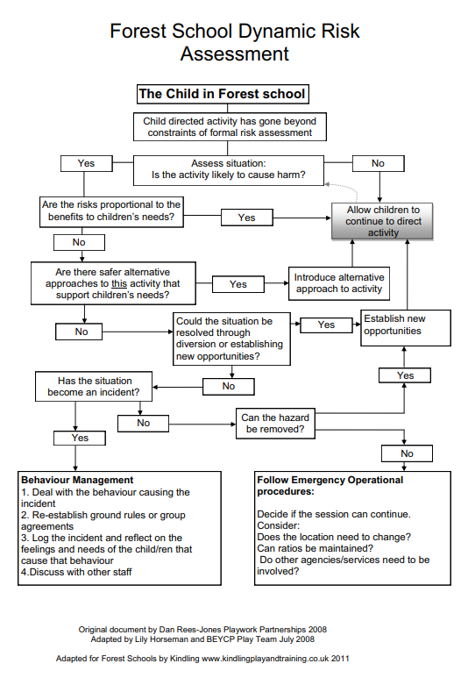

The following procedures should be followed:
• Full risk assessments are carried out for the school site and for each activity using tools, fire, string or rope.
• Dynamic risk assessments are carried out during the day, and with changing weather, notes are recorded.
• Staff and volunteers to be informed of potential risks, hazards and working methods to minimise these. Appropriate training and instruction must be given to everyone.
• Everyone (children, staff, and volunteers) should be involved in risk assessing, minimising hazards and evaluating safe practices.
• Any accident or near miss must be recorded and evaluated.
Risks must be considered; however, some benefits can be gained. Taking risks is an essential part of learning and development, and we want to provide a safe and supportive environment where our pupils can learn about risks, challenges, and personal safety.
The Forest School ethos for managing risks is to assess risk versus benefit initially. For example
Activity/ experience | Learning and benefits
Fire | - Science in action  - Fine motor skills  - Learning to be safe/ stay safe  - Learning the properties of fire  - Experiencing the magic of fire  - Social development  - Empowering trust  - Confidence  - Holistic development  - Prep/ sorting/ planning  - Schemers  - More knowledgeable others  - Vocabulary  - Colour  - Demystifies  - Connects to human history
Rope swing | - Proprioception  - Overcoming fear
Whittling | - Responsibility  - Self esteem  - Tactic for controlling feelings  - Awareness of others  - Resilience  - Resourcefulness  - Persistence
Shelters and dens | - Collaborate  - Self-worth  - Teamwork  - Creative  - Safe space

Equipment Needed
• First Aid Kit
• Bin Bags
• A copy of the consent forms
• Mobile Phone
• A copy of the risk assessment
• Spare drinking water
• Spare Sun cream, spare warm top, spare waterproof
• All individual information and medication for participants
• Specific equipment for activities
• Spare water

Lost Child Procedures
If a child becomes lost while at Forest School, procedures will be followed to ensure a systematic approach to finding the child and to consider the child's risk level.
If a child is lost, we will ensure a search is made for the child as soon as possible, parents will be notified at the appropriate stage, and a high level of care will be maintained for other children while procedures are followed.
A quick search of the surrounding areas will take place. While the initial search is underway, the Forest School Leader will make enquiries of all adults to establish the last sighting and time, the clothes the child was wearing, and the child's mental state (happy, upset, etc.).
The Forest School leader will then telephone the police and report the situation, and follow their advice. The parent or carer will be contacted. Telephone lines should remain as free as possible to avoid message delays.
The activities for the remaining children will continue as normal, and staff not involved in the search will give the children proper attention.
Any incidents are recorded in the Emergency Procedures Record.

General Session Standards
Our Forest School sessions are run by a qualified Level 3 Forest School Leader, who is also a qualified First Aider, and include outdoor First Aid.
The FSL follows the following structure.
Leader's responsibilities before the activity:
• A routine visual and physical check of the equipment to be used
• First Aid equipment is available throughout the session
• Update on site / generic risk assessment if needed
• Collect the group and complete the signing-out sheet
• Sign out medication of individual pupils (if necessary)
During the session, the Leader is responsible for:
• Setting out the aims of the session • Running the session with a suitable level of challenge • Group management during the activity • Personal development
On completion of the session, the Leader is responsible for:
• Feedback / review to pupils (through talking, pictures, 'thumbs up / thumbs down') • Checking equipment for damage/recording use/completing logs as required
• Reporting accidents / near misses (Behaviour Watch)
• Collecting and returning the equipment
• Leaving the site/facility in a clean and safe condition (as specified in our code of conduct section)

Forest School Consent/Medical Form

Host School:

Name of child ……………………………………………………………………………………………………………………….
Date of birth ……………………………………… Religion (if applicable) .…….………………..…………………..

Current Address………..……………………………………………………………………………………………………

Postcode………..………………………………… (PLEASE ENSURE YOUR POSTCODE IS INCLUDED)

Parent/Guardian……..…..…………………………………………………………………………………………………………

How could you be contacted in the case of an emergency?

Tel no home ........……………………………………………………………………………………………………………

Tel no work.........…………………………………………………………………………………………………………………

Mobile…………………………………………………………………………………………………………………………………

Alternative Contact Person…..………..……………………………… Tel no…….……………………………

I permit my son/daughter …………………………………………………… to take part in the forest school project. I have ensured that my child understands that it is important for their safety and for the safety of the group that any rules and instructions given by the staff are adhered to.

I understand that, while the Forest School staff in charge of the group will take all reasonable care for the young people, they cannot be held responsible for any loss, damage or injury suffered by my son/daughter, unless they are negligent.

Any medical condition or allergy we should know about (eg: asthma, material, food, insect bites, etc.)………………………………………………………………………………………………………………………………

Treatment required…………………………………………………………………………………………………………….

……………………………………………………………………………………………………………………………………………

Has your child received a vaccination against Tetanus in the last five years?

....................................................................................................................................................

Please give details of any recent infectious or contagious diseases that your child has had in the last 3 months
.………………………………………………………………………………………………………………………………………………
.………………………………………………………………………………………………………………………………………………

Name, address and telephone number of child's doctor……………………………………………………….

………………………………………………………………………………………………………………………………………………

I consent to any emergency medical treatment necessary during the visit.

Could you please indicate whether you permit photos of your child to be taken? These may be used for school publicity and the website

PLEASE CIRCLE: YES…………………. NO…………………

Your child will only be allowed to attend forest school sessions if they have the following items of clothing –

- Long trousers - must be worn by ALL children
- Wellingtons or sturdy outdoor shoes
- Extra warm socks – especially if wearing Wellingtons
- Waterproof jacket
- Waterproof trousers or spare trousers (i.e. jogging bottoms)
- Warm fleece
- Warm coat
- Hat, gloves, scarf

Please tick the box to confirm the above

Signed ……………………………………………… (Parent/Guardian) Date.............…………………

Communication strategy for exchanging information with those assisting with Forest School and other interested parties

Head teacher/ Deputy Head teacher
Governors
Teachers whose classes will be attending Forest School sessions
All school staff
Helpers – Teaching assistants/ parent helpers
Parents and carers
Parish Council Conservation Group

What will I do, and/or what am I going to do, to inform interested parties about what is happening in Forest School, or what is going to happen?

- A copy of the Handbook containing relevant policies and procedures will be given to the Head, Deputy Head and Governors of Earl Soham Primary School. All members of staff at Earl Soham Primary School will be informed via Gmail that the document is available on the school's website.
- All staff will be invited to ask questions about Forest School, and, if required, a presentation will be made at a convenient time.
- Information regarding Forest School and Forest School training with Suffolk Wildlife Trust will be made available in the staff room. CPD days may be of interest to other members of staff.

Parents and carers
- Cover letter on school-headed paper
- Provide the document 'A guide to Forest School for parents and carers'
- Has the consent/medical form been returned to school?
- Advise parents and carers in the cover letter where the display board is.

Staff and parent helpers
- Provide the document 'A Guide to Forest School for Helpers'
- Have all staff and helpers involved in Forest School signed to confirm they have read and understood the Handbook containing the policies and procedures?
- Advise all staff where the display board is, and any additional information will be communicated on the notice board in the staffroom.

In advance of Forest School sessions – refer to the form.

- Check that all children have returned the consent form
- Check the First aid kit
- Check equipment/ tools in good working order
- Share Risk assessments with the adults involved
- Share Plans with the adults involved
- All adults have signed to confirm they have read the Handbook, including the policies and procedures.
- All adults have returned their medical forms.

On the day to complete the checklist, refer to the form.

- Weather forecast – storms?
- Site visit/ assessment
- Equipment/ tools required for experiences
- The school's emergency mobile phone is to be collected from the office
- Piriton to be collected from the office
- First aid kit
- Gate key
- Are children all wearing appropriate clothing?
- Head count
- Adult-to-child ratio
- Sign out when leaving the school and sign in on return

Following sessions

- Feedback from adults involved – appropriate experiences/ activities? What could work better? Behaviour/ issues that arise and need attention? Ideas?
- Observations from adults involved to add to their own observations
- Share plans and adjust for next session as required – does anything need to change/ be added/ specific children's learning needs (schemas, etc.)

Do the teachers of individual children want feedback? The head? The governors? Refer them to the display board. Arrange meetings to discuss individual children.

Workplace/Location: Earl Soham Primary School  Earl Soham IP13 7SA | Date of assessment: 05/01/2026 | Review date: 05/01/2027
Risk assessor's name: Samina Stoney  Nearest A&E – Ipswich Hospital IP4 5PD | Job title: Class teacher/Forest School Leader | General site risk assessment: Earl Soham grounds and conservation area

HAZARD IDENTIFIED | RISK ARISING FROM HAZARD | CONTROL MEASURES IN PLACE | RISK RATING
 |  |  | SEV | PRO | RISK | Risk adequate (Y/N)  If N0- specify additional precautions required
Falling trees/branches (hanging deadwood) | Injury or death | Site RA, provide briefings to all staff, volunteers, and students on potential hazards | 3 | 1 | 3 | Yes, all control measures are always in place.
Uneven terrain | Slips, trips, or falls leading to breaks or sprains | Inspects the site for hazards, pointing them out during the initial safety talk. Keep the site and tools tidy. Wear appropriate clothing and stout footwear. | 2 | 2 | 4 | Yes, all control measures are always in place.
Harmful plants, eg, fungi, sap, thorns, spores and pollen | Allergic reactions, skin irritations, cuts and scratches, inflammation, infection, septicaemia, hay fever, asthma, disease | No plant, fruit or fungi should be eaten unless you are sure it is edible. Deadly nightshade is very harmful if eaten. Thorns from blackthorn, if not removed, can become septic. Contact with sap and other plant material can be avoided by wearing suitable clothing. Wash off skin/irrigate eyes thoroughly with clean water without delay if irritation occurs. If serious swelling, refer to a doctor. | 2 | 2 | 4 | Yes, all control measures are always in place.
Dangerous/harmful animal, e.g. snake bites or insect stings | Lyme's disease, poisoning, inflammation, infection, allergic reactions, and skin irritation | Encourage the use of long sleeves and long trousers. Raise awareness of risk. Do not disturb wild animals. Remove ticks and report bites to a doctor. | 2 | 2 | 4 | Yes, all control measures are always in place.
Extreme weather: heat, sun, cold, sudden downpour and high winds | Sunburn, heat stroke, hyper/hypo thermia, exposure/exhaustion, dehydration, injury or death | Fresh drinking water is always available. Wet weather outer layer, gloves and warm clothing. Use sunscreen (even on a hazy day) and a sun hat. Leader to monitor ongoing conditions and to stop the session promptly if people are clearly inappropriately dressed for conditions, in discomfort or in high winds. |  |  |  | Yes, all control measures are always in place.

Workplace/Location: Earl Soham Primary School  Earl Soham IP13 7SA | Date of assessment: 05/01/2026 | Review date: 05/01/2027
Risk assessor's name: Samina Stoney  Nearest A&E – Ipswich Hospital IP4 5PD | Job title: Class teacher/Forest School Leader | General activity risk assessment for:  Cooking on an open fire
HAZARD IDENTIFIED | RISK ARISING FROM HAZARD | CONTROL MEASURES IN PLACE | RISK RATING |  |  |  | Risk benefit
 |  |  | SEV | PRO | RISK | Risk adequate (Y/N)  If N0- specify additional precautions required
Boiling a kettle | Burns from picking up the kettle | Thick welding gauntlet to be used when removing the kettle from the fire.  Adults only to pour hot water | 2 | 2 | 4 | Yes, all control measures are always in place. | Cooking together promotes confidence, self-esteem, and independence in meeting a basic human need. It builds community and encourages sharing. Teaches about managing risk, the importance of focusing on a set of tasks, as well as obvious links to healthy living and the science of different cooking processes.
Cooking food | Food poisoning | Food to be probed at 72 degrees for 2 minutes before serving | 2 | 1 | 2 | Yes, all control measures are always in place.
Cooking food | Burns from charcoal | Close supervision of all cooking by staff | 2 | 1 | 2 | Yes, all control measures are always in place.
Cooking food | Burns from hot fat | Close supervision of all cooking by staff | 1 | 1 | 1 | Yes, all control measures are always in place.
Transporting and storing food | Food contamination/poisoning | Food to be transported in a food-safe cool box with ice packs, maintaining low temperatures |  |  |  | Yes, all control measures are always in place.

Workplace/Location: Earl Soham Primary School  Earl Soham IP13 7SA | Date of assessment: 05/01/2026 | Review date: 05/01/2027
Risk assessor's name: Samina Stoney  Nearest A&E – Ipswich Hospital IP4 5PD | Job title: Class teacher/Forest School Leader | General activity risk assessment for: Fires

HAZARD IDENTIFIED | RISK ARISING FROM HAZARD | CONTROL MEASURES IN PLACE | RISK RATING |  |  |  | Risk benefit
 |  |  | SEV | PRO | RISK | Risk adequate (Y/N)  If N0- specify additional precautions required
Making fires | Burns from lighting | Fling and steel used to light fires (this uses both hands, so it is less likely to cause burns). Any Vaseline used should be applied inside a cotton pad, not on the hands. | 3 | 2 | 6 | Yes, all control measures are always in place. | Fire perseverance and fine motor skills. Problem-solving by trying different techniques
Tending to the fire | Burns | Fire to be fed with one piece of wood at a time under adult supervision and placed on, not thrown. | 3 | 1 | 3 | Yes, all control measures are always in place. | Students learn about managing risk, health and safety, and considering the whole group. About special awareness and gross motor skills. Learning to light a fire is a survival skill and links to science.
Tending to the fire | Falling into the fire | Only designated fire feeders and staff are to be inside the fire circle once the fire is lit | 3 | 2 | 6 | Yes, all control measures are always in place.
Tending to the fire | Hair and clothing catching alight. | All long hair must be tied back. flapping sleeves to be tucked in or rolled back. | 3 | 2 | 6 | Yes, all control measures are always in place.
Tending to the fire | Fire spreading | Clearly marked and defined fire pit surrounded by green logs. Fire size to be controlled by staff. | 3 | 1 | 3 | Yes, all control measures are always in place.

Workplace/Location: Earl Soham Primary School  Earl Soham IP13 7SA | Date of assessment: 05/01/2026 | Review date: 05/01/2027
Risk assessor's name: Samina Stoney  Nearest A&E – Ipswich Hospital IP4 5PD | Job title: Class teacher/Forest School Leader | General activity risk assessment for:  Games

HAZARD IDENTIFIED | RISK ARISING FROM HAZARD | CONTROL MEASURES IN PLACE |  | RISK RATING |  |  |  |  | Risk benefit
 |  |  |  | SEV | PRO | RISK | Risk adequate (Y/N)  If N0- specify additional precautions required
Stumps and other trip hazards | Fall, sprain, breaks, cuts | Verbal warnings and playing running games on the field |  | 2 | 2 | 4 | Yes, all control measures are always in place. |  | Develops gross motor skills and coordination  Aids, trust and teamwork are fun. Improves physical fitness.  Creates an opportunity to discuss fairness, winner/loser, etc., and improves self-esteem
Brambles, nettles and insect bites | Stings, cuts and bites | Verbal warnings |  | 1 | 1 | 1 | Yes, all control measures are always in place.
 | Bumped heads | Clear instructions/ verbal warnings. If blindfolded, ensure the adult ratio is high. Adults to 'steer' players away from obstacles |  | 1 | 1 | 1 | Yes, all control measures are always in place.
Workplace/Location: Earl Soham Primary School  Earl Soham io13 7SA |  |  | Date of assessment: 05/01/2026 |  |  |  |  | Review date: 05/01/2027
Risk assessor's name: Samina Stoney  Nearest A&E – Ipswich Hospital IP4 5PD |  |  | Job title: Class teacher/Forest School Leader |  |  |  |  | General activity risk assessment for: Rope work

HAZARD IDENTIFIED | RISK ARISING FROM HAZARD | CONTROL MEASURES IN PLACE | RISK RATING |  |  |  | Risk benefit
 |  |  | SEV | PRO | RISK | Risk adequate (Y/N)  If N0- specify additional precautions required
Falling from a rope/balance/swing | Sprains and rope burn | 1:1 supervision by staff or work in 3's. Balance ropes a maximum of 18" off the ground | 1 | 3 | 3 | Yes, all control measures are always in place. | Teaches balance and coordination as well as team skills, trust and self-confidence
Ropes coming untied | Falling, sprains and twists | Double-check all knots used | 2 | 1 | 2 | Yes, all control measures are always in place.
If using blindfolds- trip hazard and low branches | Stumbles, sprains, and twists  Cuts from low twigs or bramble | All dangerous foliage to be removed from the eye height area before a blindfold game  Remove trip hazards if practical or point out the hazard | 1 | 3 | 3 | Yes, all control measures are always in place. | Good trust exercise, special awareness, balance and coordination

Workplace/Location: Earl Soham Primary School  Earl Soham IP13 7SA | Date of assessment: 05/01/2026 | Review date: 05/01/2027
Risk assessor's name: Samina Stoney  Nearest A&E – Ipswich Hospital IP4 5PD | Job title: Class teacher/Forest School Leader | General activity risk assessment for:  Using sharp tools, e.g. for whittling, sawing, and slitting logs

HAZARD IDENTIFIED | RISK ARISING FROM HAZARD | CONTROL MEASURES IN PLACE | RISK RATING |  |  |  | Risk benefit
 |  |  | SEV | PRO | RISK | Risk adequate (Y/N)  If N0- specify additional precautions required | Teaches fine motor skills as well as gross motor (chopping wood)  Teaches management of own risks. Using tools to whittle or create green woodwork items encourages creativity, problem-solving, team building and perseverance  And most importantly, it is very calming and therapeutic
Saws or peelers slipping | cuts | Instructions on the use of tools by staff  Wear gloves on the non-tool-using hand. Model correct use and close supervision | 3 | 2 | 6 | Yes, all control measures are always in place.
Inappropriate use or transportation of tools | Cuts and eye injury | Verbal warnings and instructions on tool use. Make formal agreements with everyone around safe tool use. Model correct methods of use and transportation | 3 | 1 | 3 | Yes, all control measures are always in place.
Tools left  Around unused unsheathed and unguarded | cuts | Instructions given on the importance of replacing guards on tools or sheaths.  All tools returned to the toolbox immediately after use | 3 | 1 | 3 | Yes, all control measures are always in place.

Workplace/Location: Earl Soham Primary School  Earl Soham IP13 7SA | Date of assessment: 05/01/2026 | Review date: 05/01/2027
Risk assessor's name: Samina Stoney  Nearest A&E – Ipswich Hospital IP4 5PD | Job title: Class teacher/Forest School Leader | General activity risk assessment for: Shelter building

HAZARD IDENTIFIED | RISK ARISING FROM HAZARD | CONTROL MEASURES IN PLACE | RISK RATING |  |  |  | Risk benefit
 |  |  | SEV | PRO | RISK | Risk adequate (Y/N)  If N0- specify additional precautions required
Brambles, nettles and damaged wood | Splinters, stings from nettles and cuts from brambles | Verbal warnings and gloves are available | 1 | 2 | 2 | Yes, all control measures are always in place. | Problem solving, teamwork, fine and gross motor skills  Developing creativity  Shelter building fulfils a need to create a safe space
Moving heavy timber, potentially dropping on limbs  Handling rough logs | Strains, grazing or bruising | Verbal warnings, gloves available  Model safe handling and correct construction | 1 | 1 | 1 | Yes, all control measures are always in place.

