Movers and Shakers
Year 1 and 2 Year A
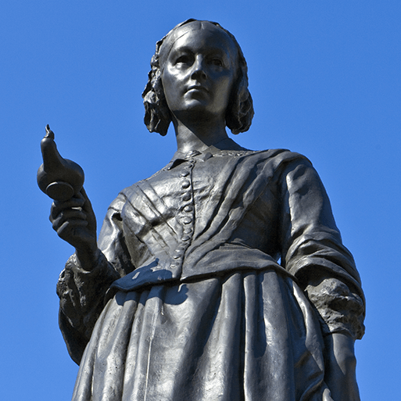
Learn about changes within living memory. Where appropriate, these should be used to reveal aspects of change in national life.
Learn about events beyond living memory that are significant nationally or globally.
Learn about the lives of significant individuals in the past who have contributed to national and international achievements. Some should be used to compare aspects of life in different periods.
Learn about significant historical events, people and places in their own locality.
Understand the methods of historical enquiry, including how evidence is used rigorously to make historical claims, and discern how and why contrasting arguments and interpretations of the past have been constructed.

Magnificent Monarchs
Year 1 and 2 Year A
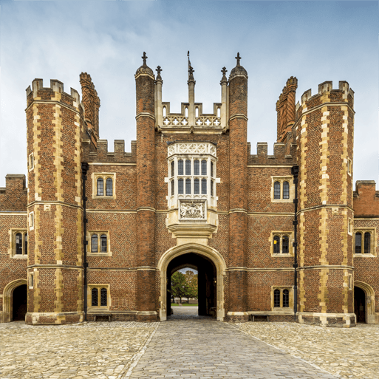
Learn about changes within living memory. Where appropriate, these should be used to reveal aspects of change in national life.
Learn about events beyond living memory that are significant nationally or globally.
Learn about the lives of significant individuals in the past who have contributed to national and international achievements. Some should be used to compare aspects of life in different periods.
Gain and deploy a historically grounded understanding of abstract terms such as ‘empire’, ‘civilisation’, ‘parliament’ and ‘peasantry’.
Understand historical concepts such as continuity and change, cause and consequence, similarity, difference and significance, and use them to make connections, draw contrasts, analyse trends, frame historically valid questions and create their own structured accounts, including written narratives and analyses.
Understand the methods of historical enquiry, including how evidence is used rigorously to make historical claims, and discern how and why contrasting arguments and interpretations of the past have been constructed.

Childhood
Year 1 and 2 Year B
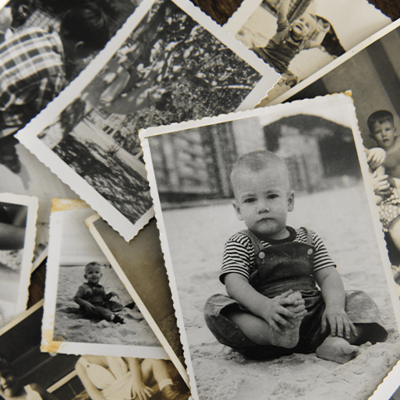
Learn about changes within living memory. Where appropriate, these should be used to reveal aspects of change in national life.
Learn about events beyond living memory that are significant nationally or globally.
Learn about significant historical events, people and places in their own locality.
Know and understand the history of these islands as a coherent, chronological narrative, from the earliest times to the present day: how people’s lives have shaped this nation and how Britain has influenced and been influenced by the wider world.
Understand historical concepts such as continuity and change, cause and consequence, similarity, difference and significance, and use them to make connections, draw contrasts, analyse trends, frame historically valid questions and create their own structured accounts, including written narratives and analyses.
Understand the methods of historical enquiry, including how evidence is used rigorously to make historical claims, and discern how and why contrasting arguments and interpretations of the past have been constructed.
Bright Lights, Big City
Year 1 and 2 Year B
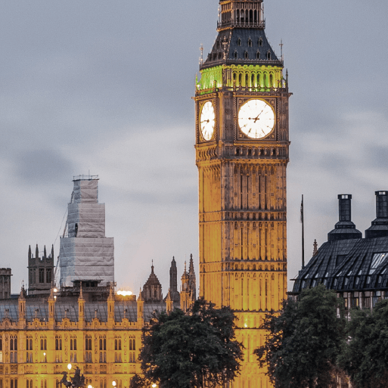
Learn about events beyond living memory that are significant nationally or globally.
Gain and deploy a historically grounded understanding of abstract terms such as ‘empire’, ‘civilisation’, ‘parliament’ and ‘peasantry’.

Lower Key Stage 2
Through the Ages
Year 3 and 4 Year A
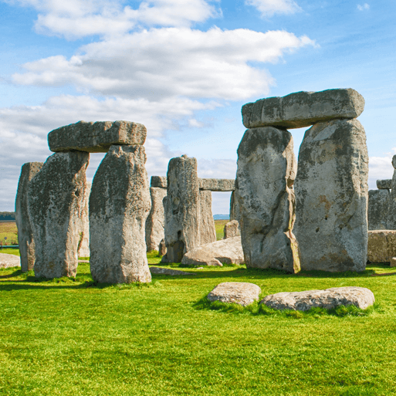
Learn about changes in Britain from the Stone Age to the Iron Age.
Know and understand the history of these islands as a coherent, chronological narrative, from the earliest times to the present day: how people’s lives have shaped this nation and how Britain has influenced and been influenced by the wider world.
Understand historical concepts such as continuity and change, cause and consequence, similarity, difference and significance, and use them to make connections, draw contrasts, analyse trends, frame historically valid questions and create their own structured accounts, including written narratives and analyses.
Understand the methods of historical enquiry, including how evidence is used rigorously to make historical claims, and discern how and why contrasting arguments and interpretations of the past have been constructed.

Emperors and Empires
Year 3 and 4 Year A
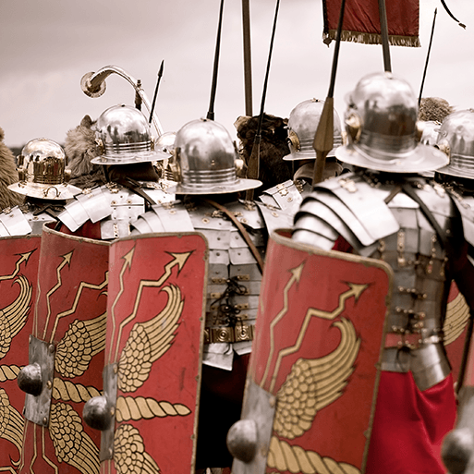
Learn about the Roman Empire and its impact on Britain.
Conduct a local history study.
Know and understand the history of these islands as a coherent, chronological narrative, from the earliest times to the present day: how people’s lives have shaped this nation and how Britain has influenced and been influenced by the wider world.
Understand historical concepts such as continuity and change, cause and consequence, similarity, difference and significance, and use them to make connections, draw contrasts, analyse trends, frame historically valid questions and create their own structured accounts, including written narratives and analyses.
Understand the methods of historical enquiry, including how evidence is used rigorously to make historical claims, and discern how and why contrasting arguments and interpretations of the past have been constructed.

Invasion
Year 3 and 4 Year B
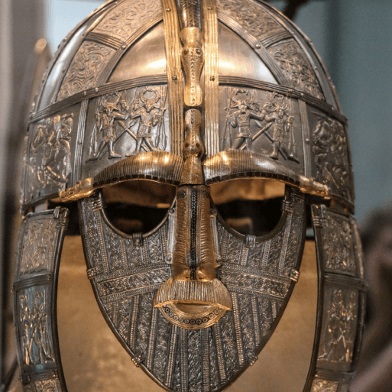
Learn about the Viking and Anglo-Saxon struggle for the Kingdom of England to the time of Edward the Confessor.
Conduct a local history study.
Study an aspect or theme in British history that extends pupils’ chronological knowledge beyond 1066.
Understand historical concepts such as continuity and change, cause and consequence, similarity, difference and significance, and use them to make connections, draw contrasts, analyse trends, frame historically valid questions and create their own structured accounts, including written narratives and analyses.
Understand the methods of historical enquiry, including how evidence is used rigorously to make historical claims, and discern how and why contrasting arguments and interpretations of the past have been constructed.
Gain historical perspective by placing their growing knowledge into different contexts: understanding the connections between local, regional, national and international history; between cultural, economic, military, political, religious and social history; and between short- and long-term timescales.
Ancient Civilisations
Year 3 and 4 Year B
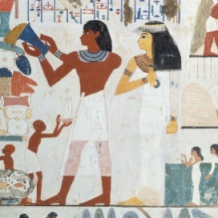
Learn about the achievements of the earliest civilizations – an overview of where and when the first civilizations appeared and a depth study of one of the following: Ancient Sumer; The Indus Valley; Ancient Egypt; The Shang Dynasty of Ancient China.
Gain and deploy a historically grounded understanding of abstract terms such as ‘empire’, ‘civilisation’, ‘parliament’ and ‘peasantry’.
Understand historical concepts such as continuity and change, cause and consequence, similarity, difference and significance, and use them to make connections, draw contrasts, analyse trends, frame historically valid questions and create their own structured accounts, including written narratives and analyses.
Understand the methods of historical enquiry, including how evidence is used rigorously to make historical claims, and discern how and why contrasting arguments and interpretations of the past have been constructed.
Gain historical perspective by placing their growing knowledge into different contexts: understanding the connections between local, regional, national and international history; between cultural, economic, military, political, religious and social history; and between short- and long-term timescales.

Off with Her Head
Year 5 and 6 Year A
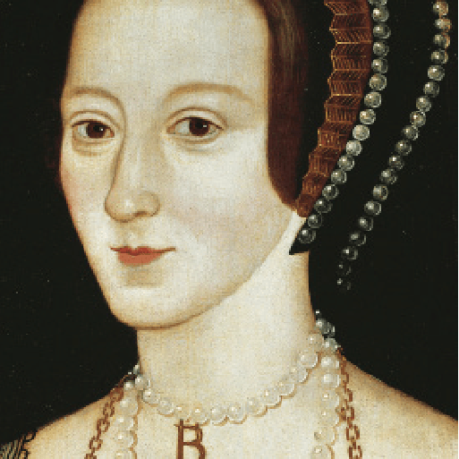
Create an in-depth study of an aspect of British history beyond 1066
Explore and explain how the religious, political, scientific or personal beliefs of a significant individual caused them to behave in a particular way.
Articulate and organise important information and detailed historical accounts using topic related vocabulary.
Ask and answer historically valid questions
Groundbreaking Greeks
Year 5 and 6 Year A
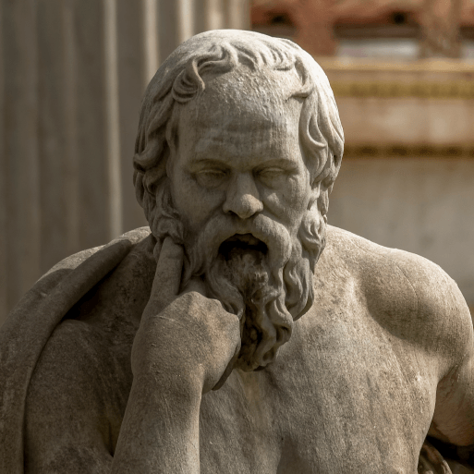

Learn about Ancient Greece – a study of Greek life and achievements and their influence on the western world.
Know and understand significant aspects of the history of the wider world: the nature of ancient civilisations; the expansion and dissolution of empires; characteristic features of past non-European societies; achievements and follies of mankind.
Gain and deploy a historically grounded understanding of abstract terms such as ‘empire’, ‘civilisation’, ‘parliament’ and ‘peasantry’.
Understand historical concepts such as continuity and change, cause and consequence, similarity, difference and significance, and use them to make connections, draw contrasts, analyse trends, frame historically valid questions and create their own structured accounts, including written narratives and analyses.
Understand the methods of historical enquiry, including how evidence is used rigorously to make historical claims, and discern how and why contrasting arguments and interpretations of the past have been constructed.
Gain historical perspective by placing their growing knowledge into different contexts: understanding the connections between local, regional, national and international history; between cultural, economic, military, political, religious and social history; and between short- and long-term timescales.
Maafa
Year 5 and 6 Year B
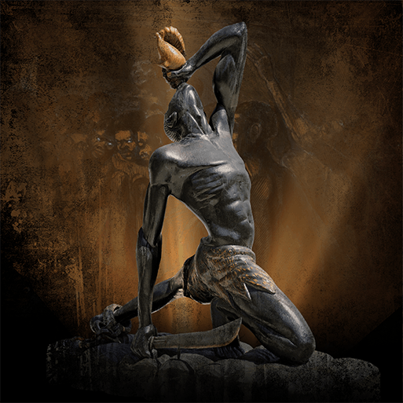
Study an aspect or theme in British history that extends pupils’ chronological knowledge beyond 1066.
Know and understand significant aspects of the history of the wider world: the nature of ancient civilisations; the expansion and dissolution of empires; characteristic features of past non-European societies; achievements and follies of mankind.
Gain and deploy a historically grounded understanding of abstract terms such as ‘empire’, ‘civilisation’, ‘parliament’ and ‘peasantry’.
Understand historical concepts such as continuity and change, cause and consequence, similarity, difference and significance, and use them to make connections, draw contrasts, analyse trends, frame historically valid questions and create their own structured accounts, including written narratives and analyses.
Understand the methods of historical enquiry, including how evidence is used rigorously to make historical claims, and discern how and why contrasting arguments and interpretations of the past have been constructed.

Hola Mexico!
Year 5 and 6 Year B
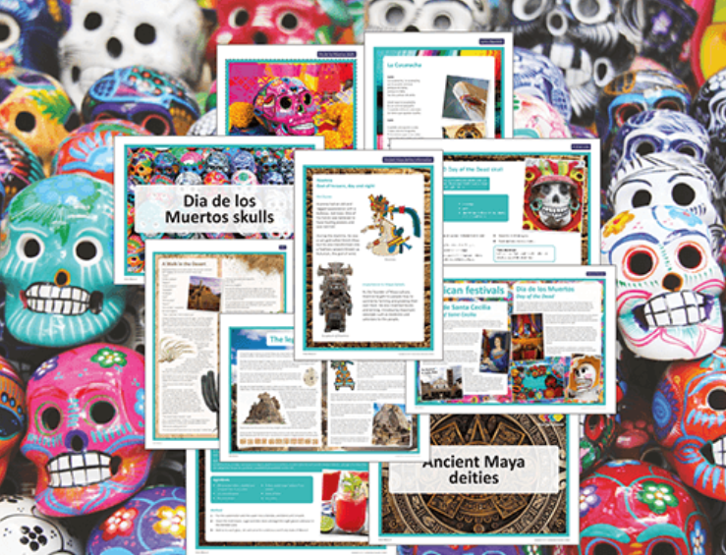
Learn about a non-European society that provides contrasts with British history – one study chosen from: early Islamic civilization, including a study of Baghdad c. AD 900; Mayan civilization c. AD 900; Benin (West Africa) c. AD 900-1300.

