

Coverage in KS2

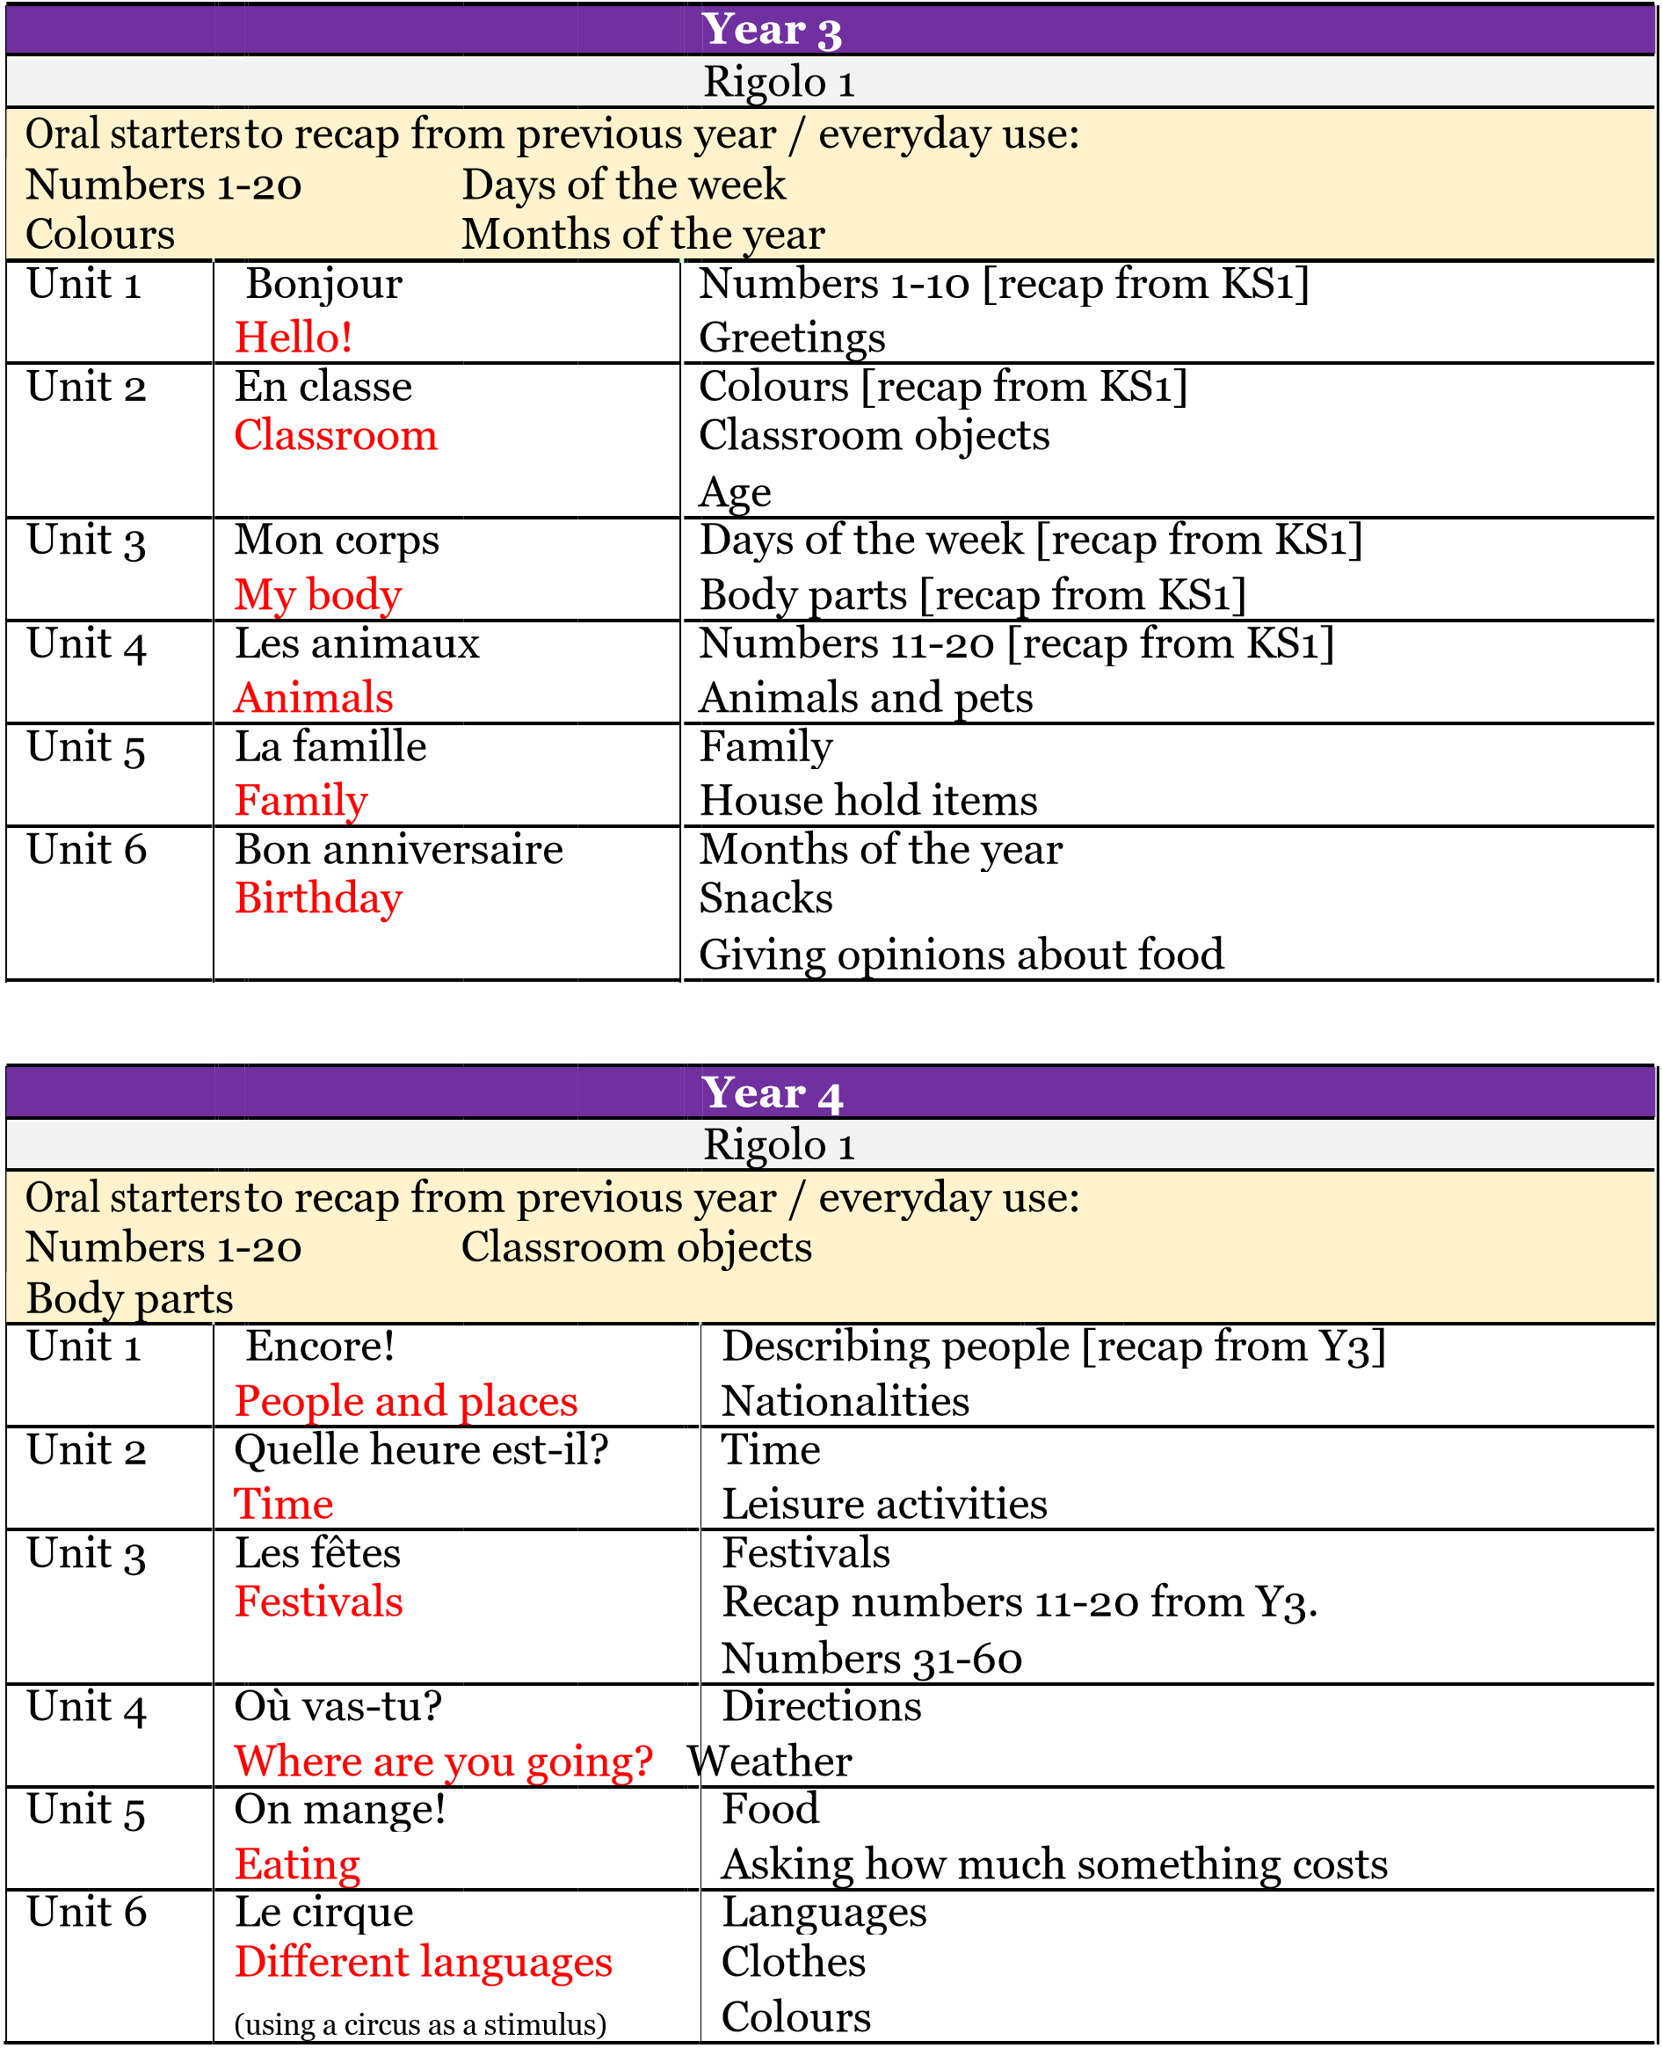

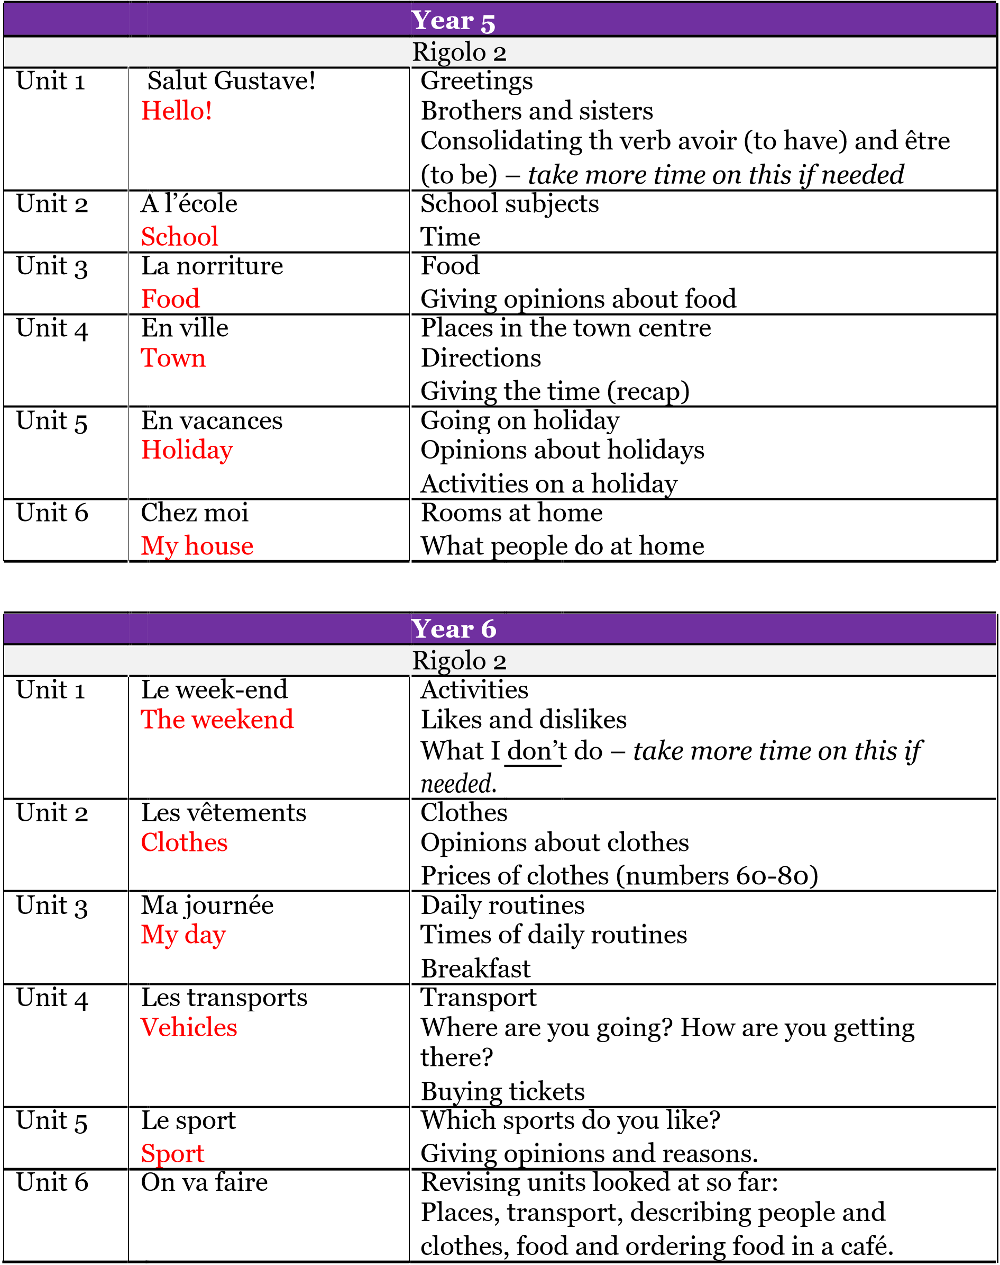

Grammar

At the end of each year KS2 children should be able to write simple sentences based on the unit they have covered. This could be about one aspect of what they covered
or a variety.

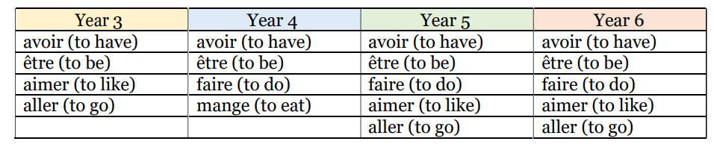

Key Stage 1

Whilst MFL isn’t a requirement for KS1 pupils, there are some skills that can be practised orally with the children.

Numbers 0 – 20

https://www.youtube.com/watch?v=UsEz58BblMY

Colours

Using colouring pencils, shout out a colour, ask children to hold the colour.

https://www.youtube.com/watch?v=kzR_d6uJkb8

Days of the week

https://www.youtube.com/watch?v=BiHYehk0tYo

Body parts

Head shoulders, knees and toes song:

https://www.youtube.com/watch?v=7RJVwMGRiZs

