- Swift Class Year A
- Animal Survival
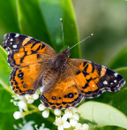 | Use simple fieldwork and observational skills to study the geography of their school and its grounds and the key human and physical features of its surrounding environment.
- Swift Class Year A

Coastline

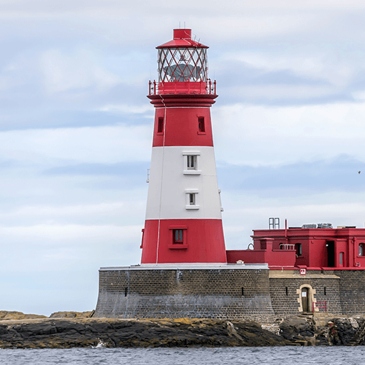 | Name and locate the world’s seven continents and five oceans.  Name, locate and identify characteristics of the four countries and capital cities of the UK and its surrounding seas.  Use basic geographical vocabulary to refer to key physical features, including: beach, cliff, coast, forest, hill, mountain, sea, ocean, river, soil, valley, vegetation, season and weather.  Use basic geographical vocabulary to refer to key human features, including: city, town, village, factory, farm, house, office, port, harbour and shop.  Use world maps, atlases and globes to identify the UK and its countries, as well as the countries, continents and oceans studied at this key stage.  Use simple compass directions (North, South, East and West) and locational and directional language (e.g. near and far; left and right), to describe the location of features and routes on a map.  Use aerial photographs and plan perspectives to recognise landmarks and basic human and physical features; devise a simple map; and use and construct basic symbols in a key.  Use simple fieldwork and observational skills to study the geography of their school and its grounds and the key human and physical features of its surrounding environment.  Develop contextual knowledge of the location of globally significant places – both terrestrial and marine – including their defining physical and human characteristics and how these provide a geographical context for understanding the actions of processes.  Understand the processes that give rise to key physical and human geographical features of the world, how these are interdependent and how they bring about spatial variation and change over time.  Are competent in the geographical skills needed to: collect, analyse and communicate with a range of data gathered through experiences of fieldwork that deepen their understanding of geographical processes; interpret a range of sources of geographical information, including maps, diagrams, globes, aerial photographs and Geographical Information Systems (GIS); communicate geographical information in a variety of ways, including through maps, numerical and quantitative skills and writing at length.
- Swift Class Year A
- Let’s explore the world
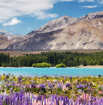 | Name and locate the world’s seven continents and five oceans.  Name, locate and identify characteristics of the four countries and capital cities of the UK and its surrounding seas.  Understand geographical similarities and differences through studying the human and physical geography of a small area of the UK, and of a small area in a contrasting non-European country.  Identify seasonal and daily weather patterns in the UK and the location of hot and cold areas of the world in relation to the Equator and the North and South Poles.
- Swift Class Year A
- Magnificent Monarchs
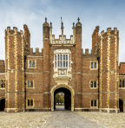 | Use aerial photographs and plan perspectives to recognise landmarks and basic human and physical features; devise a simple map; and use and construct basic symbols in a key.  Develop contextual knowledge of the location of globally significant places – both terrestrial and marine – including their defining physical and human characteristics and how these provide a geographical context for understanding the actions of processes.
- Swift Class Year A
- Movers and Shakers
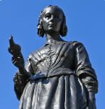 | Develop contextual knowledge of the location of globally significant places – both terrestrial and marine – including their defining physical and human characteristics and how these provide a geographical context for understanding the actions of processes.
- Swift Class Year A
- Uses of Materials
 | Use simple fieldwork and observational skills to study the geography of their school and its grounds and the key human and physical features of its surrounding environment.
- Swift Class Year B
- Childhood
 | Use simple fieldwork and observational skills to study the geography of their school and its grounds and the key human and physical features of its Understand the processes that give rise to key physical and human geographical features of the world, how these are interdependent and how they bring about spatial variation and change over time. surrounding environment.
- Swift Class Year B

Our Wonderful World
 | Name and locate the world’s seven continents and five oceans.  Name, locate and identify characteristics of the four countries and capital cities of the UK and its surrounding seas.  Understand geographical similarities and differences through studying the human and physical geography of a small area of the UK, and of a small area in a contrasting non-European country.  Identify seasonal and daily weather patterns in the UK and the location of hot and cold areas of the world in relation to the Equator and the North and South Poles.  Use basic geographical vocabulary to refer to key physical features, including: beach, cliff, coast, forest, hill, mountain, sea, ocean, river, soil, valley, vegetation, season and weather.  Use basic geographical vocabulary to refer to key human features, including: city, town, village, factory, farm, house, office, port, harbour and shop.  Use world maps, atlases and globes to identify the UK and its countries, as well as the countries, continents and oceans studied at this key stage.  Use simple compass directions (North, South, East and West) and locational and directional language (e.g. near and far; left and right), to describe the location of features and routes on a map.  Use aerial photographs and plan perspectives to recognise landmarks and basic human and physical features; devise a simple map; and use and construct basic symbols in a key  Use simple fieldwork and observational skills to study the geography of their school and its grounds and the key human and physical features of its surrounding environment.
- Swift Class Year B
- Bright Lights, Big City

 | Name, locate and identify characteristics of the four countries and capital cities of the UK and its surrounding seas.  Understand geographical similarities and differences through studying the human and physical geography of a small area of the UK, and of a small area in a contrasting non-European country.  Identify seasonal and daily weather patterns in the UK and the location of hot and cold areas of the world in relation to the Equator and the North and South Poles.  Use basic geographical vocabulary to refer to key physical features, including: beach, cliff, coast, forest, hill, mountain, sea, ocean, river, soil, valley, vegetation, season and weather.  Human and physical geography  Use basic geographical vocabulary to refer to key human features, including: city, town, village, factory, farm, house, office, port, harbour and shop.  Use world maps, atlases and globes to identify the UK and its countries, as well as the countries, continents and oceans studied at this key stage.  Use simple compass directions (North, South, East and West) and locational and directional language (e.g. near and far; left and right), to describe the location of features and routes on a map.  Use aerial photographs and plan perspectives to recognise landmarks and basic human and physical features; devise a simple map; and use and construct basic symbols in a key.  Use simple fieldwork and observational skills to study the geography of their school and its grounds and the key human and physical features of its surrounding environment.  Develop contextual knowledge of the location of globally significant places – both terrestrial and marine – including their defining physical and human characteristics and how these provide a geographical context for understanding the actions of processes.
- Swift Class Year B
- Dinosaur Planet
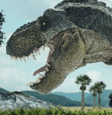 | Name and locate the world’s seven continents and five oceans.  Use simple fieldwork and observational skills to study the geography of their school and its grounds and the key human and physical features of its surrounding environment.  Understand the processes that give rise to key physical and human geographical features of the world, how these are interdependent and how they bring about spatial variation and change over time.
- Swift Class Year B
- Seasonal Changes
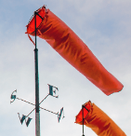 | Understand the processes that give rise to key physical and human geographical features of the world, how these are interdependent and how they bring about spatial variation and change over time.

Red Panda Class Year A

One Planet, Our World

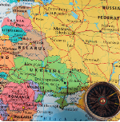 | Are competent in the geographical skills needed to: collect, analyse and communicate with a range of data gathered through experiences of fieldwork that deepen their understanding of geographical processes; interpret a range of sources of geographical information, including maps, diagrams, globes, aerial photographs and Geographical Information Systems (GIS); communicate geographical information in a variety of ways, including through maps, numerical and quantitative skills and writing at length.  Locate the world’s countries, using maps to focus on Europe (including the location of Russia) and North and South America, concentrating on their environmental regions, key physical and human characteristics, countries, and major cities.  Name and locate counties and cities of the United Kingdom, geographical regions and their identifying human and physical characteristics, key topographical features (including hills, mountains, coasts and rivers), and land-use patterns; and understand how some of these aspects have changed over time.  Identify the position and significance of latitude, longitude, Equator, Northern Hemisphere, Southern Hemisphere, the Tropics of Cancer and Capricorn, Arctic and Antarctic Circle, the Prime/Greenwich Meridian and time zones (including day and night).  Understand geographical similarities and differences through the study of human and physical geography of a region of the United Kingdom, a region in a European country, and a region within North or South America.  Describe and understand key aspects of physical geography, including: climate zones, biomes and vegetation belts, rivers, mountains, volcanoes and earthquakes, and the water cycle.  Describe and understand key aspects of human geography, including: types of settlement and land use, economic activity including trade links, and the distribution of natural resources including energy, food, minerals and water.  Use maps, atlases, globes and digital/computer mapping to locate countries and describe features studied.  Use the eight points of a compass, four and six-figure grid references, symbols and key (including the use of Ordnance Survey maps) to build their knowledge of the United Kingdom and the wider world.  Use fieldwork to observe, measure, record and present the human and physical features in the local area using a range of methods, including sketch maps, plans and graphs, and digital technologies.
- Red Panda Class Year A
- Rocks, Rumbles and Relics

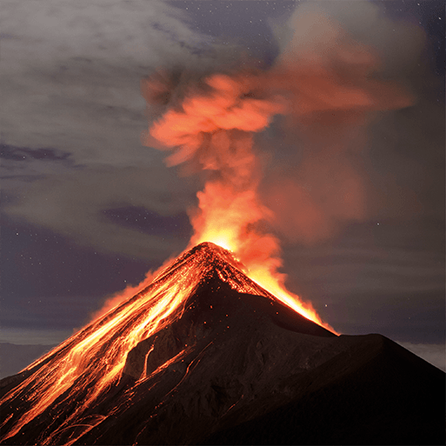 | Understand the processes that give rise to key physical and human geographical features of the world, how these are interdependent and how they bring about spatial variation and change over time.  Locate the world’s countries, using maps to focus on Europe (including the location of Russia) and North and South America, concentrating on their environmental regions, key physical and human characteristics, countries, and major cities.  Identify the position and significance of latitude, longitude, Equator, Northern Hemisphere, Southern Hemisphere, the Tropics of Cancer and Capricorn, Arctic and Antarctic Circle, the Prime/Greenwich Meridian and time zones (including day and night).  Understand geographical similarities and differences through the study of human and physical geography of a region of the United Kingdom, a region in a European country, and a region within North or South America.  Describe and understand key aspects of physical geography, including: climate zones, biomes and vegetation belts, rivers, mountains, volcanoes and earthquakes, and the water cycle.
- Red Panda Class Year A
- Through the Ages

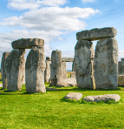 | Describe and understand key aspects of human geography, including: types of settlement and land use, economic activity including trade links, and the distribution of natural resources including energy, food, minerals and water.
- Red Panda Class Year B
- Electrical Circuits and Conductors
 | Describe and understand key aspects of human geography, including: types of settlement and land use, economic activity including trade links, and the distribution of natural resources including energy, food, minerals and water.
- Red Panda Class Year B
- Misty Mountain, Winding River

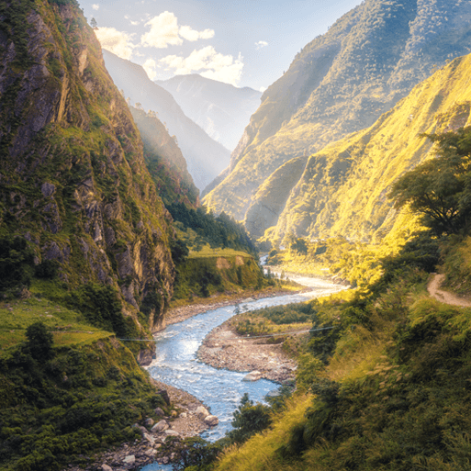 | Understand the processes that give rise to key physical and human geographical features of the world, how these are interdependent and how they bring about spatial variation and change over time.  Locate the world’s countries, using maps to focus on Europe (including the location of Russia) and North and South America, concentrating on their environmental regions, key physical and human characteristics, countries, and major cities.  Name and locate counties and cities of the United Kingdom, geographical regions and their identifying human and physical characteristics, key topographical features (including hills, mountains, coasts and rivers), and land-use patterns; and understand how some of these aspects have changed over time.  Understand geographical similarities and differences through the study of human and physical geography of a region of the United Kingdom, a region in a European country, and a region within North or South America.  Describe and understand key aspects of physical geography, including: climate zones, biomes and vegetation belts, rivers, mountains, volcanoes and earthquakes, and the water cycle.  Describe and understand key aspects of human geography, including: types of settlement and land use, economic activity including trade links, and the distribution of natural resources including energy, food, minerals and water.  Use maps, atlases, globes and digital/computer mapping to locate countries and describe features studied.  Use the eight points of a compass, four and six-figure grid references, symbols and key (including the use of Ordnance Survey maps) to build their knowledge of the United Kingdom and the wider world.  Use fieldwork to observe, measure, record and present the human and physical features in the local area using a range of methods, including sketch maps, plans and graphs, and digital technologies.
- Red Panda Class Year B
- Interconnected World
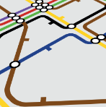 | Are competent in the geographical skills needed to: collect, analyse and communicate with a range of data gathered through experiences of fieldwork that deepen their understanding of geographical processes; interpret a range of sources of geographical information, including maps, diagrams, globes, aerial photographs and Geographical Information Systems (GIS); communicate geographical information in a variety of ways, including through maps, numerical and quantitative skills and writing at length.  Locate the world’s countries, using maps to focus on Europe (including the location of Russia) and North and South America, concentrating on their environmental regions, key physical and human characteristics, countries, and major cities.  Name and locate counties and cities of the United Kingdom, geographical regions and their identifying human and physical characteristics, key topographical features (including hills, mountains, coasts and rivers), and land-use patterns; and understand how some of these aspects have changed over time.  Identify the position and significance of latitude, longitude, Equator, Northern Hemisphere, Southern Hemisphere, the Tropics of Cancer and Capricorn, Arctic and Antarctic Circle, the Prime/Greenwich Meridian and time zones (including day and night).  Understand geographical similarities and differences through the study of human and physical geography of a region of the United Kingdom, a region in a European country, and a region within North or South America.  Describe and understand key aspects of physical geography, including: climate zones, biomes and vegetation belts, rivers, mountains, volcanoes and earthquakes, and the water cycle.  Describe and understand key aspects of human geography, including: types of settlement and land use, economic activity including trade links, and the distribution of natural resources including energy, food, minerals and water.  Use maps, atlases, globes and digital/computer mapping to locate countries and describe features studied.  Use the eight points of a compass, four and six-figure grid references, symbols and key (including the use of Ordnance Survey maps) to build their knowledge of the United Kingdom and the wider world.
- Red Panda Class Year B
- Invasion
 | Use maps, atlases, globes and digital/computer mapping to locate countries and describe features studied.
- Sunbear Class Year A
- Groundbreaking Greeks
 | Use maps, atlases, globes and digital/computer mapping to locate countries and describe features studied.
- Sunbear Class Year A
- Sow, Grow and Farm

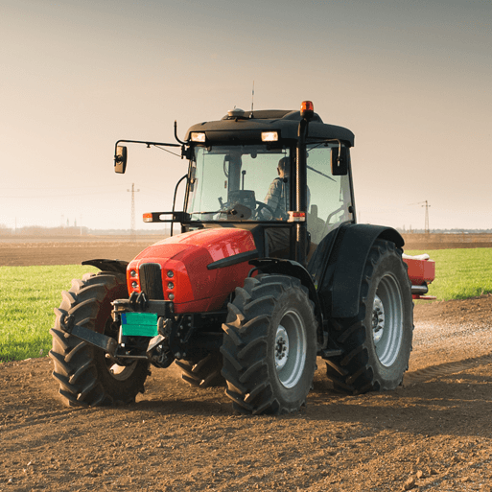 | Are competent in the geographical skills needed to: collect, analyse and communicate with a range of data gathered through experiences of fieldwork that deepen their understanding of geographical processes; interpret a range of sources of geographical information, including maps, diagrams, globes, aerial photographs and Geographical Information Systems (GIS); communicate geographical information in a variety of ways, including through maps, numerical and quantitative skills and writing at length.  Locate the world’s countries, using maps to focus on Europe (including the location of Russia) and North and South America, concentrating on their environmental regions, key physical and human characteristics, countries, and major cities.  Describe and understand key aspects of physical geography, including: climate zones, biomes and vegetation belts, rivers, mountains, volcanoes and earthquakes, and the water cycle.  3 7  Human and physical geography  KS2  25  Describe and understand key aspects of human geography, including: types of settlement and land use, economic activity including trade links, and the distribution of natural resources including energy, food, minerals and water.  Use the eight points of a compass, four and six-figure grid references, symbols and key (including the use of Ordnance Survey maps) to build their knowledge of the United Kingdom and the wider world.
- Sunbear Class Year A
- Investigating Our World
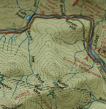 | Understand the processes that give rise to key physical and human geographical features of the world, how these are interdependent and how they bring about spatial variation and change over time.  Locate the world’s countries, using maps to focus on Europe (including the location of Russia) and North and South America, concentrating on their environmental regions, key physical and human characteristics, countries, and major cities.  Name and locate counties and cities of the United Kingdom, geographical regions and their identifying human and physical characteristics, key topographical features (including hills, mountains, coasts and rivers), and land-use patterns; and understand how some of these aspects have changed over time.  Identify the position and significance of latitude, longitude, Equator, Northern Hemisphere, Southern Hemisphere, the Tropics of Cancer and Capricorn, Arctic and Antarctic Circle, the Prime/Greenwich Meridian and time zones (including day and night).  Understand geographical similarities and differences through the study of human and physical geography of a region of the United Kingdom, a region in a European country, and a region within North or South America.  Describe and understand key aspects of physical geography, including: climate zones, biomes and vegetation belts, rivers, mountains, volcanoes and earthquakes, and the water cycle.  Describe and understand key aspects of human geography, including: types of settlement and land use, economic activity including trade links, and the distribution of natural resources including energy, food, minerals and water.  Use maps, atlases, globes and digital/computer mapping to locate countries and describe features studied.  Use the eight points of a compass, four and six-figure grid references, symbols and key (including the use of Ordnance Survey maps) to build their knowledge of the United Kingdom and the wider world.  Use fieldwork to observe, measure, record and present the human and physical features in the local area using a range of methods, including sketch maps, plans and graphs, and digital technologies.
- Sunbear Class Year B
- Hola Mexico
 | Identify the position and significance of latitude, longitude, Equator, Northern Hemisphere, Southern Hemisphere, the Tropics of Cancer and Capricorn, Arctic and Antarctic Circle, the Prime/Greenwich Meridian and time zones (including day and night).  Describe and understand key aspects of human geography, including: types of settlement and land use, economic activity including trade links, and the distribution of natural resources including energy, food, minerals and water.  Use the eight points of a compass, four and six-figure grid references, symbols and key (including the use of Ordnance Survey maps) to build their knowledge of the United Kingdom and the wider world.
- Sunbear Class Year B
- Frozen Kingdoms
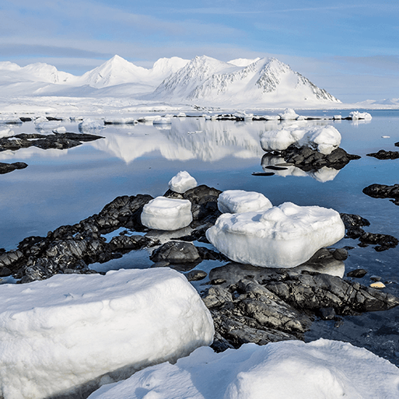 | Understand the processes that give rise to key physical and human geographical features of the world, how these are interdependent and how they bring about spatial variation and change over time.  Are competent in the geographical skills needed to: collect, analyse and communicate with a range of data gathered through experiences of fieldwork that deepen their understanding of geographical processes; interpret a range of sources of geographical information, including maps, diagrams, globes, aerial photographs and Geographical Information Systems (GIS); communicate geographical information in a variety of ways, including through maps, numerical and quantitative skills and writing at length.  Identify the position and significance of latitude, longitude, Equator, Northern Hemisphere, Southern Hemisphere, the Tropics of Cancer and Capricorn, Arctic and Antarctic Circle, the Prime/Greenwich Meridian and time zones (including day and night).  Understand geographical similarities and differences through the study of human and physical geography of a region of the United Kingdom, a region in a European country, and a region within North or South America.  Describe and understand key aspects of physical geography, including: climate zones, biomes and vegetation belts, rivers, mountains, volcanoes and earthquakes, and the water cycle.  Describe and understand key aspects of human geography, including: types of settlement and land use, economic activity including trade links, and the distribution of natural resources including energy, food, minerals and water.  Use fieldwork to observe, measure, record and present the human and physical features in the local area using a range of methods, including sketch maps, plans and graphs, and digital technologies.
- Sunbear Class Year B
- Maafa
 | Describe and understand key aspects of human geography, including: types of settlement and land use, economic activity including trade links, and the distribution of natural resources including energy, food, minerals and water.
- Sunbear Class Year B
- Our Changing World
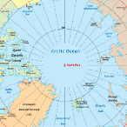 | Describe and understand key aspects of physical geography, including: climate zones, biomes and vegetation belts, rivers, mountains, volcanoes and earthquakes, and the water cycle.  Describe and understand key aspects of human geography, including: types of settlement and land use, economic activity including trade links, and the distribution of natural resources including energy, food, minerals and water.  Use maps, atlases, globes and digital/computer mapping to locate countries and describe features studied.  Use the eight points of a compass, four and six-figure grid references, symbols and key (including the use of Ordnance Survey maps) to build their knowledge of the United Kingdom and the wider world.  Use fieldwork to observe, measure, record and present the human and physical features in the local area using a range of methods, including sketch maps, plans and graphs, and digital technologies.  Are competent in the geographical skills needed to: collect, analyse and communicate with a range of data gathered through experiences of fieldwork that deepen their understanding of geographical processes; interpret a range of sources of geographical information, including maps, diagrams, globes, aerial photographs and Geographical Information Systems (GIS); communicate geographical information in a variety of ways, including through maps, numerical and quantitative skills and writing at length.  Locate the world’s countries, using maps to focus on Europe (including the location of Russia) and North and South America, concentrating on their environmental regions, key physical and human characteristics, countries, and major cities.  Name and locate counties and cities of the United Kingdom, geographical regions and their identifying human and physical characteristics, key topographical features (including hills, mountains, coasts and rivers), and land-use patterns; and understand how some of these aspects have changed over time.  Identify the position and significance of latitude, longitude, Equator, Northern Hemisphere, Southern Hemisphere, the Tropics of Cancer and Capricorn, Arctic and Antarctic Circle, the Prime/Greenwich Meridian and time zones (including day and night).  Develop contextual knowledge of the location of globally significant places – both terrestrial and marine – including their defining physical and human characteristics and how these provide a geographical context for understanding the actions of processes.

